VersionOne

Salesforce

Integration Guide

Table of Contents

Introduction 3

System Requirements 3

VersionOne 3

Salesforce 3

Installation 4

Configuration 4

Pre-Installation 4

Post-Installation 5

Using the VersionOne Salesforce Integration 13

Create VersionOne Defects from Salesforce Cases 13

Update Salesforce Cases with Defect Statuses from VersionOne 14

Disassociate VersionOne Defects from Salesforce Cases 15

Associate Salesforce Cases with Existing VersionOne Defects 15

# Introduction

VersionOne’s integration with Salesforce, also known as “CaseConnect”, provides the ability to create or link defects in VersionOne with cases in Salesforce. Using this integration your organization can leverage its investment in Salesforce case management as part of an integrated platform for Agile development. Salesforce users can choose to create a new VersionOne defect or associate the Salesforce case to an existing VersionOne defect. After the association is made, the Salesforce user can view the VersionOne defect from Salesforce, view the Salesforce case from VersionOne, and refresh the VersionOne defect status in the Salesforce case.

Specifically, the integration allows Salesforce users to:

* Create VersionOne defects from cases in Salesforce.
* Associate Salesforce cases with existing defects in VersionOne.
* Update Salesforce cases with defect statuses from VersionOne.
* Un-assign or disassociate defects in VersionOne from Salesforce cases.

# System Requirements

## VersionOne

The integration is supported with the following VersionOne editions:

* Team
* Catalyst
* Enterprise
* Ultimate

Note that your VersionOne instance must be accessible from the internet in order to use the integration.

## Salesforce

The integration has been tested with the Summer 2010 to Spring 2012 releases of Salesforce.

# Installation

The integration is available on the [Salesforce AppExchange](http://appexchange.salesforce.com/results?type=Apps&keywords=versionone) site and is installed into your Salesforce instance from that location and is provided without any additional license fees or costs.

# Configuration

Configuration of the integration is relatively straightforward, but there are a few simple pre and post installation steps that you will need to take.

## Pre-Installation

Prior to installing the integration, you will need to add “Salesforce” as a valid source in VersionOne by doing the following:

1. Log into VersionOne as a member with Administrator privileges.
2. Click **Administration** to display the drop down menu.
3. Select **List Types**.
4. Click the **Global** tab. The top grid contains a list of valid source values.
5. If Salesforce is not already in this list of sources:
   1. Click **Add**.
   2. Enter **Salesforce** in the Title field.
   3. Click **Ok**.

When completed, your screen should appear similar to Figure 1:

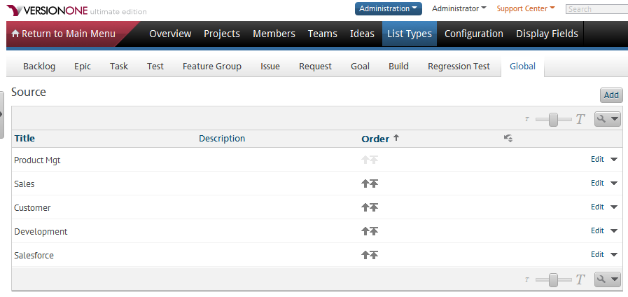

Figure 1: Source List Types

Once the pre-installation is completed, you may proceed with installing the integration from the Salesforce AppExchange site.

## Post-Installation

After the installation has been successfully installed in your Salesforce instance, you will need to make the following configurations in Salesforce:

* Add your VersionOne instance as a valid remote site in Salesforce.
* Configure the VersionOne settings.
* Configure your Salesforce cases PageLayout to include the custom VersionOne fields.

The following sections describe how to perform each of these steps.

**Adding a Remote Site**

To access VersionOne from your Salesforce instance you need to add your VersionOne instance as a remote site by doing the following:

1. Log into your Salesforce instance.
2. Click your personal menu then select **Setup** to access your personal setup page.
3. In vertical menu located on the left, expand **Security Controls**, which is located under **Administration Setup**.
4. Click **Remote Site Settings** to display the list of remote sites configured for your Salesforce instance.
5. Click the **New Remote Site** button to display the **Remote Site Edit** screen.
6. Enter **VersionOne** for the **Remote Site Name** as shown in Figure 2.
7. Enter the URL of your VersionOne instance for the **Remote Site URL** as shown in Figure 2.
8. Click **Save**.

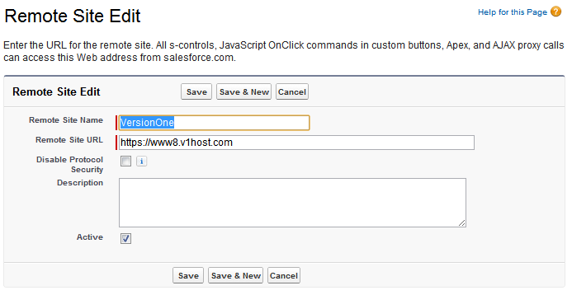

Figure 2: Salesforce Remote Site Edit

When completed, your VersionOne remote site entry should appear in the All Remote Sites screen as shown in Figure 3.

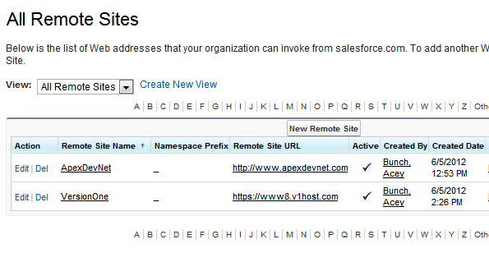

Figure 3: Salesforce All Remote Sites

**Configuring the VersionOne Settings**

The integration includes a custom settings tab that allows you to specify the VersionOne instance that will be integrated with your Salesforce instance, along with the VersionOne member account used to create the defects. The supported settings include:

|  |  |
| --- | --- |
| **Field** | **Description** |
| URL to VersionOne | The URL for your VersionOne instance. |
| Username | The username for a valid VersionOne member with access to the VersionOne projects where you want to create the defects. |
| Password | The password for specified user. |
| Source | The source list value you entered in VersionOne in the pre-installation steps. By default this should be the same value that you created for the source list type in VersionOne, which should be **Salesforce**. |

You can configure the VersionOne integration settings by doing the following:

1. While still in Salesforce, click the **All Tabs** button (the plus sign) in your Salesforce horizontal menu to open the All Tabs screen.
2. Click the **VersionOne Settings** link as it appears in Figure 4 to open the Settings for VersionOne Integration screen as shown in Figure 5.
3. Enter the URL for your VersionOne instance in the **URL to VersionOne** field as shown in Figure 5. Note that your URL maybe different.
4. Enter the username in the **Username** field as shown in Figure 5. Note that the user account that you use may be different.
5. Enter the password for the user account in the **Password** field as shown in Figure 5.
6. Enter **Salesforce** for in the **Source** field as shown in Figure 5.
7. Click the **Test Settings** button to verify that your settings are correct.
8. Click the **Save Settings** button to save your VersionOne integration settings.

Once the integration settings are saved successfully, the Version Project for Defect Creation section will appear on the screen. This section allows you to specify which VersionOne project that the defects will be created in, and the Salesforce products codes that are allowed to submit a defect.

The first entry in the list is the default mapping, which is used when a Salesforce product code cannot be found in the list, or if the product code field is left blank in the Salesforce case. You cannot remove this entry, but you can choose which VersionOne project is used. If you want to have all defects from Salesforce go into a single project in VersionOne, you do not need to create any additional mappings. Note that using a single mapping is beneficial for initial testing because it limits where you need to look when creating defects.

To add a new mapping do the following:

1. Select a Salesforce product code from the drop down list.
2. Select the desired VersionOne project from the drop down list.
3. Click **Add**.

Once an entry has been added you can update the entry by making the desired change and clicking the **Update** link on the desired row. You may also remove an entry by clicking the **Remove** link on the desired row.

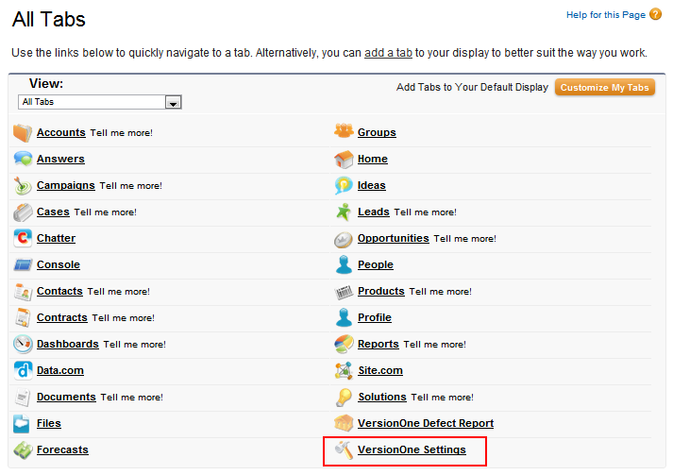

Figure 4: Salesforce All Tabs

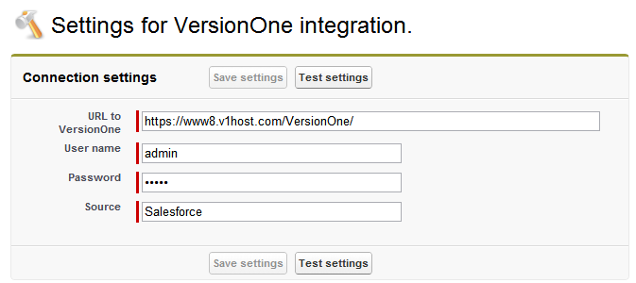

Figure 5: Salesforce Settings for VersionOne Integration

**Configuring the Case Page Layout**

The final step in configuring your Salesforce instance is to make the custom integration fields available to your Salesforce users by modifying their case page layout. By default, the integration contains a custom page layout called **Case (VersionOne) Layout**, which you can set as the default layout, or you can modify an existing layout.

The custom VersionOne case page layout contains all of the VersionOne custom integration fields, but it does not contain any case page layout customizations you may already have in your environment. It is included in the integration package for testing and as a model for adding the custom VersionOne fields to an existing case page layout. However, if you have not customized your existing Salesforce case page layout, you may find that replacing it with the custom VersionOne case page layout is preferred.

If you do not want to use the custom VersionOne case page layout, you can modify one of your existing case page layouts to include the custom VersionOne fields. Detailed instructions for modifying an existing case page layout can be found in the Salesforce help system.

You can set the default case page layout to the VersionOne custom layout in Salesforce by doing the following:

1. Click your personal menu then select **Setup** to access your personal setup page.
2. In vertical menu located on the left, expand **Customize**, which is located under **App Setup**.
3. Click to expand **Cases**.
4. Click the **Page Layouts** link to open the Case Page Layout screen as shown in Figure 6.
5. In the Case Page Layout screen, click the **Page Layout Assignment** button to open the Page Layout Assignment screen as shown in Figure 7.
6. Click the **Edit Assignment** button to open the Edit Page Layout Assignment screen as shown in Figure 8.
7. Select the profile to assign the page layout to in the Profiles grid.
8. Select **Case (VersionOne) Layout** from the **Page Layout To Use** drop down list to assign the page layout to the profile.
9. Click the **Save** button to save the case page layout assignment.

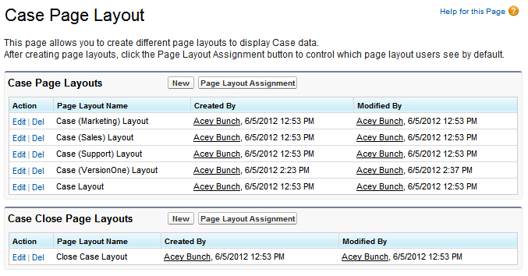

Figure 6: Salesforce Case Page Layout

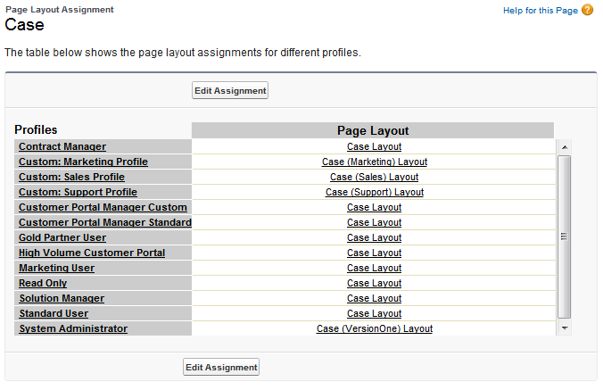

Figure 7: Salesforce Page Layout Assignment

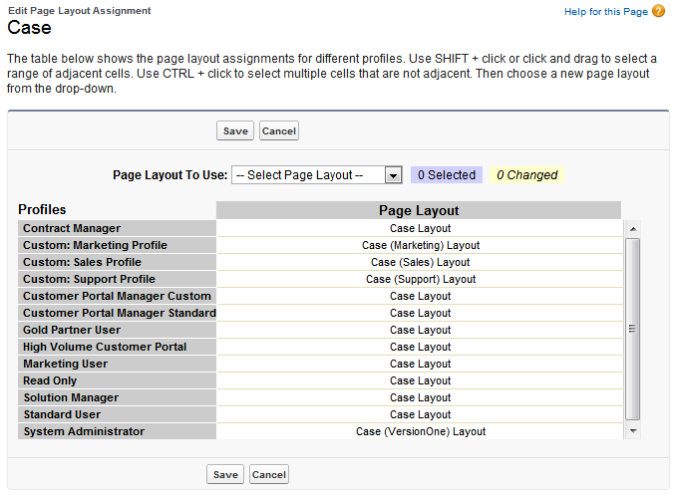

Figure 8: Salesforce Edit Page Layout Assignment

Once the VersionOne custom case page layout has been set, users assigned to use that layout will see the custom VersionOne sections and fields as highlighted (in red) in Figure 9 when the use the Cases screen in Salesforce.

***Note****: If the Cases tab is not visible within Salesforce, use the click the* ***All Tabs*** *(the plus sign) button within Salesforce then click the* ***Customize My Tabs*** *button to assign the Cases tab to your application.*

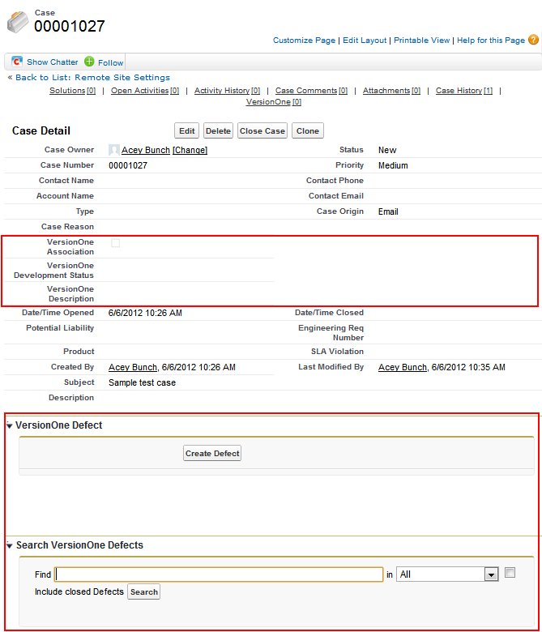

Figure 9: Salesforce VersionOne Case Layout

# Using the VersionOne Salesforce Integration

The VersionOne integration with Salesforce is a simple yet powerful way to associate Salesforce cases with VersionOne defects, and to update the status of those defects from VersionOne to Salesforce. Once the integration has been installed and properly configured, using the integration is fairly simple, and there are essentially four areas of integration workflow:

* Create VersionOne defects from cases in Salesforce.
* Associate Salesforce cases with existing defects in VersionOne.
* Update Salesforce cases with defect statuses from VersionOne.
* Un-assign or disassociate defects in VersionOne from Salesforce cases.

The following sections discuss how to make use of each of these workflow areas.

## Create VersionOne Defects from Salesforce Cases

Creating a defect from an existing Salesforce case is accomplished with a simple click of the Create Defect button in the VersionOne defect section of the custom VersionOne case page layout as shown in Figure 10.

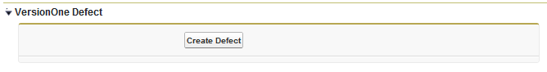

Figure 10: Salesforce VersionOne Defect Creation

Once the button is clicked, a defect in created in the project specified in the VersionOne integration settings, and a table is displayed in the case page layout that displays the VersionOne ID for the defect, its title, and the project that it was created in as shown in Figure 10.

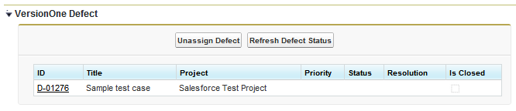

Figure 11: Salesforce VersionOne Defect Display

Clicking the VersionOne ID link in the defect table will launch VersionOne and display the defect. In addition, once the associatation has been established, the Salesforce case can be opened in version on by clicking the Salesforce case link while viewing the details of the defect in VersionOne as shown in Figure 12.

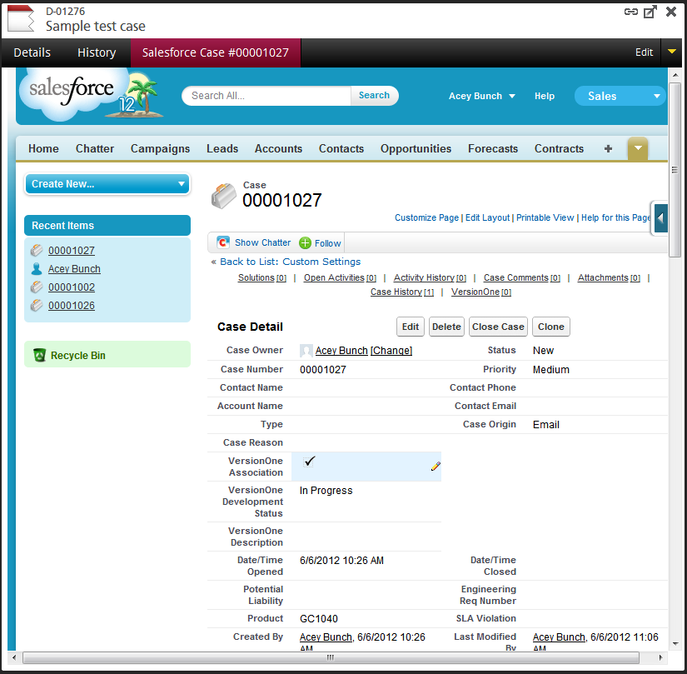

Figure 13: Salesforce Case Display in VersionOne Defect

## Update Salesforce Cases with Defect Statuses from VersionOne

Once a defect status has been updated in VersionOne, that status can be refreshed in the associated Salesforce case by clicking the Refresh Defect Status button in the VersionOne Defect section of the case layout as shown in Figure 11. The defect status will appear in the VersionOne Development Status field in the case layout as shown in Figure 13.

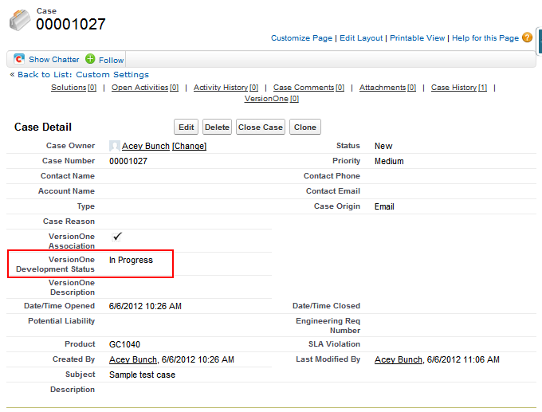

Figure 13: Salesforce VersionOne Defect Status

## Disassociate VersionOne Defects from Salesforce Cases

VersionOne defects can be disassociated with Salesforce cases by simply open the case in Salesforce then clicking the **Unassign Defect** button in the VersionOne defect section as shown in Figure 11. Note that disassociating a defect will not delete the defect in VersionOne, it will only unlink it from the Salesforce case.

## Associate Salesforce Cases with Existing VersionOne Defects

In addition to creating VersionOne defects directly from Salesforce, you can also associate an existing VersionOne defect with a Salesforce case. This is accomplished by searching for an existing VersionOne defect using the Search VersionOne Defects section of the VersionOne custom case layout as shown in Figure 14.

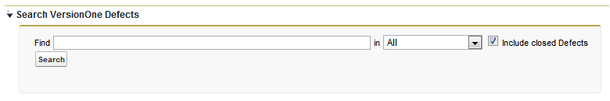

Figure 14: Salesforce Search VersionOne Defects

To search for existing VersionOne defects, enter some text to search by in the **Find** field, select the VersionOne field to search from the drop down list, then click the **Search** button. If one or more defects are found that match your search criteria, a list for those defects will appear in the Search VersionOne Defects section as shown in Figure 15.

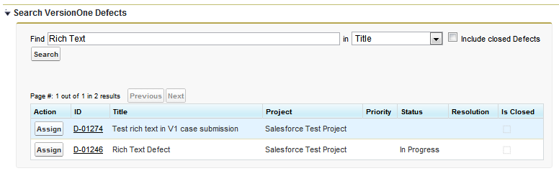

Figure 15: Salesforce Search VersionOne Defects Results

To associate a VersionOne defect with the Salesforce case, simply click the **Assign** button next to the appropriate defect.